Private Sewage System Design Document Example/Template

**Holding Tank**

PREFACE

This is an example Design Document for a holding tank system. It reflects the information needed to demonstrate the design considerations for the particular site and system required by the Private Sewage Standard of Practice 2009 (Standard) have been made. Considerations needed for a particular site may go beyond those used as an example in this document.

This example document can be used as a template by editing or adding critical information to suit the particular site and system.

While it is preferable to use a consistent format to facilitate quick review, other formats of the design document may be accepted by the Safety Codes Officer (SCO), if the document includes the required information that shows the necessary design considerations were made.

A design is required in support of a permit application. It includes drawings and supporting information as it applies to the specific site and design. This is the information a SCO will review to evaluate whether design considerations required by the Standard have been adequately made prior to issuing the permit.

Including the design in the operation and maintenance manual that must be provided to the owner, will simplify development of the operation and maintenance manual.

Private Sewage system design - Holding tank

Date:

Joe Smith

Box 1,

Somewhere, Alberta

**Subject: Residential Wastewater Holding Tank System**

**Legal Description of Property:** SE Sec 9, Twp 71, Rge. 5, W of 6 Mer.

Lot 14; Blk 1; Plan 123450

**Municipal Address:** 19035 - Rge. Rd. 5

**Introduction**

This private sewage system is for a 4-bedroom single family dwelling. Based on the characteristics of the home identified during our assessment, the total peak wastewater flow per day is 461 Imperial gallons with average operating flow of 300 gallons per day.

The sewage system is restricted to a holding tank due to the soil conditions of the property. The municipality was contacted and they have no restrictions on the installation of holding tanks. This design applies and meets the requirements of the Alberta Private Sewage Systems Standard of Practice (Standard).

1. **Wastewater Characteristics**
   1. **Wastewater Peak flow**

The development served is a 4-bedroom single-family dwelling. The total plumbing fixture unit load in this residence is 21 based on a building plans review. This requires 50 L/day (11Imp. gal/day) be added to the peak daily flow. Fixture unit load is as follows:

* + Main bath = 6 fixture units
  + Bathroom with shower off master bedroom = 6 fixture units
  + Kitchen sink = 1.5 fixture units
  + Laundry stand pipe = 1.5 fixture units
  + Bathroom in basement = 6 fixture units

|  |  |
| --- | --- |
| **Total peak daily flow used in the design is:**  **450 Imp. gal + 11 Imp. gal = 461 Imp. gal** | **2,090 L/day**  **(461 Imp. gal/day)** |

* 1. **Wastewater Strength**

Not applicable to residential holding tank.

1. **Site Evaluation Findings**

**2.1 Site Evaluation**

The lot is 0.177 hectare (0.44 acres). The dimensions of the property are shown in the drawing attached in Appendix A. The adjacent lands are small lots within a residential subdivision. There are no water courses on or adjacent this 0.177 hectare property. The property has a 2% slope toward the north property line. Line locates confirmed there are no existing utilities or easements to be considered.

The site evaluation identified a water well on this property northeast of the house site and one water well on an adjacent lot to the north. No other significant setback constraints were noted. Pertinent features identified during the site evaluation and the required setback distances are identified on the site plan in Appendix A.

**2.2 Soils Evaluation**

No soil evaluation was carried out. The soil is known to be heavy clay and unsuitable.

1. **Key Soil Characteristics**

**Not applicable**

**4 Initial Treatment Component Design Details**

Details of the initial treatment components are attached in Appendix C.

**4.1 Holding Tank**

**The working capacity of the holding tank specified is 14,456L or 3,400 Imperial gallons**. Specifications for the Model 3400H Holding Tank are shown in Appendix C. The sewage needs to be hauled to an approved site.

Burial depth of the holding tank at finished grading will be 4.5 ft above the top of the tank. The selected tank is rated for a maximum burial depth of 6 ft.–6 in. Insulation of the tank is not required as the burial depth exceeds 4 feet.

**4.2 High Liquid Level Alarm**

An Alarm Tech Inc. JB Series 1000B battery powered high level alarm is specified for this system. It shall be set to activate at 80 inches above the floor of the holding tank. This will provide approximately 477 Imp. gal of storage after the high level alarm signals, the equivalent of one day flow of sewage.

1. **Initial operational set up parameters**

The following activities need to be conducted to commission the system:

* Clean the Holding tank of any construction debris.
* Conduct test to ensure water tightness of all tank seals.
* Confirm the correct high level alarm setting.

1. **Operation and Maintenance Manual**

The Owner’s Manual detailing the design, operation, and maintenance of the installed system will be provided to the owner in accordance with Article 2.1.2.8 of the Standard of Practice.

**Attachments: Appendix A – Site Information [Site Plan]**

**Appendix B – Manufacturer’s and Design Specifications for System Components**

This design has been developed by (name of certified person and company name). This design meets the requirements of the Alberta Private Sewage Systems Standard of Practice 2009 unless specifically noted otherwise and in such case special approval is to be obtained prior to proceeding with installation of this design. *( Carry on with any other qualifications or limitations that in your opinion as the designer/installer are needed.)*

**Signature and closing by the designer/Installer.**

**Appendix A**

**Site Information**

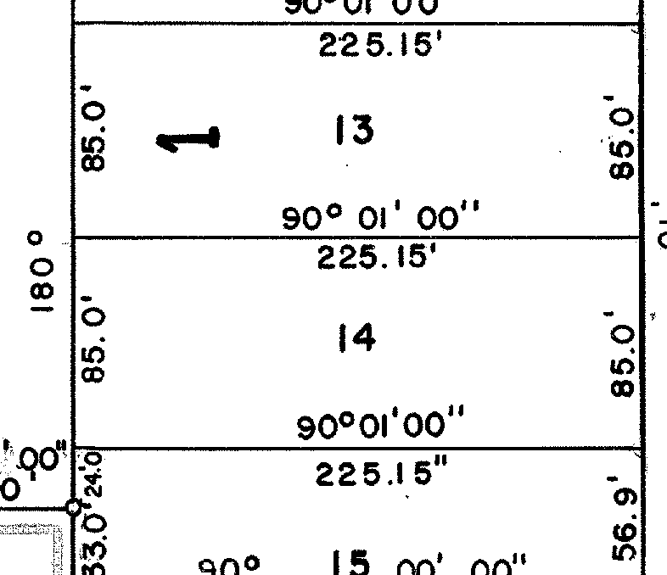

3400 gal Holding Tank 3.25 ft from house

3.25 ft

N

16 ft

32 ft

Well

35ft

House with an attached garage

**Appendix B**

**Manufacturer’s and Design Specifications for System Components**



**80 inches**

High Level Alarm

The Septic Tank Company

Mid Town,

Alberta

* 5